Spectrophotometry
Identifying Water Contaminates

Aquaspector Device
Physics, Logic, Functionally, and Research

April, 2016

By
Lance T. Walker

Abstract
The longevity of a civilization is predicted on many things, among them: its access to safe drinking water. The ability to determine the chemical or biological composition of a water supply exists beyond the reach of the majority of people, whether it be inability or inaction people fall prey to contaminated water. Both in the developing world, and in developed world cases of toxic water arise, as commonly seen in Africa, or the city of Flint, Michigan. Whilst, chemical tests already exist this project serves to investigate a possible alternative, that alternative is the use of Light to identify impurities in water. Hypothetically, there is no better comparison than an elementary particle, least of all the quantum of the electromagnetic spectrum. Photometric comparison will suffer no smaller unit of matter, resulting in lossless recognition of both chemical and biological contaminates.
All of this can be accomplished provided the testing device is designed properly, therein lies the goal and direction of this project. We must understand the traits of common contaminates, as well as distinct ways in which light interacts with substances. In order to accomplish this feat, we must utilize a variety of scientific orientations (i.e. Physics, Biology, and Chemistry) to create a device that cohesively functions to produce results that help mitigate water related health risks. The greatest issue that the project must address is the ability to make a distinction between chemical, and biological contaminates.

TABLE OF CONTENTS
ⅰ …….. Cover Sheet
ⅱ …….. Note to Readers
ⅲ …….. Abstract
ⅳ …….. Table of Contents
1.0 Water……………………………………………………………………………………………………………….……………...01
1.1 The Chemistry of Water.….………………………………………………………………….…...…………..01
1.2 Fluid Dynamics.……………………………………………………….………………………...………..……….01
1.3 Ecological Ramifications and Sustainability...…………………………………..….…………...……01
1.4 Water Contamination: Categorizations and Traits……………………………….………………..01
1.5 Water Contamination: Identifying the Source……………………………………….……………...01
1.6 Water Contamination: Purification……………………………………………………….……………….01
1.7 Water Contamination: Contingencies…………………………………………………………………...01
1.8: Synopsis………………………………………………………………………………1
2.0 Radiometry…………………………………………………………………………………….1
2.1 Introduction to Radiometry……………………………………………………………1
2.2 The Physics of the Photon……………………………………………………………..1
2.3 The Electromagnetic Spectrum………………………………………………………..1
2.4 Molecular Density of Matter…………………………………………………………..1
2.5 Processes of Attenuation………………………………………………………………1
2.6 Radiometry: Optical Methodologies…………………………………………………..1
2.7 Radiometry: Photometric Methodologies……………………………………………..1
2.8 Synopsis……………………………………………………………………………….1
3.0 Spectrophotometry…………………………………………………………………………….1
3.1 Introduction to Spectrophotometry……………………………………………………1
3.2 Photometric Conversions……………………………………………………………...1
3.3 Photometry: Electrical Operation……………………………………………………..1
3.4 Photometry: Mechanical Operation…………………………………………………...1
3.5 Photometry: Types and Methodologies……………………………………………….1
3.6 Photometry: Testing Procedures……………………………………………………...1
3.7 Synopsis……………………………………………………………………………….1
4.0 Device Information and Specifications………………………………………………………..1
4.1 Field Device: Overview……………………………………………………………….1
4.1.1 Field Device: Circuit Boards………………………………………………..1
4.1.2 Field Device: Housing………………………………………………………1
4.1.3 Field Device: Software……………………………………………………...1
4.1.4 Field Device: Spectrometer………………………………………………….1
4.1.5 Field Device: Photometer…………………………………………………...1
4.2 Faucet Device: Overview……………………………………………………………..1
4.2.1 Faucet Device: Circuit Boards………………………………………………1
4.2.2 Faucet Device: Housing……………………………………………………..1
4.2.3 Faucet Device: Software…………………………………………………….1
4.2.4 Faucet Device: Spectrometer………………………………………………..1
4.2.5 Faucet Device: Photometer………………………………………………….1
4.3 User Portal…………………………………………………………………………….1
4.3.1 Bluetooth Connection……………………………………………………….1
4.3.2 Wifi Connection……………………………………………………………..1
4.3.3 Amazon Alexa Connection………………………………………………….1
4.3.4 Alerts and Notifications……………………………………………………..1
4.4 User Maintenance……………………………………………………………………..1
4.4.1 Battery……………………………………………………………………….1
4.4.2 Calibration…………………………………………………………………...1
4.4.3 Updates……………………………………………………………………...1
4.5 Synopsis……………………………………………………………………………….1
4.5.1 Field Device: Schematics……………………………………………………1
4.5.2 Faucet Device: Schematics………………………………………………….1
5.0 Device Manufacturing and Assembly………………………………………………………...1
5.1 Circuit Board Production……………………………………………………………..1
5.2 Circuit Board Testing/Troubleshooting……………………………………………….1
5.3 3D Printing…………………………………………………………………………….1
5.4 Distribution Testing…………………………………………………………………...1
6.0 Tests and Results…………………………………………………………………1
6.1 Industry Standard Comparisons……………………………….………………………1
6.1.1 Field Device…………………………………………………………………1
6.1.2 Faucet Device…………………………………………………..……………1
6.2 Chemical Analysis…………………………………………………………….………1
6.2.1 Field Device…………………………………………………………………1
6.2.2 Faucet Device…………………………………………………..……………1
6.3 Biological Analysis……………………………………………………………………1
6.3.1 Field Device…………………………………………………………………1
6.3.2 Faucet Device…………………………………………………..……………1
6.4 Synopsis……………………………………………………………………………….1
7.0 Conclusion…………………………………………………………………………………….1
7.1 Limitations…………………………………………………………………….………1
7.2 Advancements………………………………………………………………...………1
7.3 Synopsis……………………………………………………...……………………….1
8.0 References…………………………………………………………………………………….1
9.0 Appendices…………………………………………………………………………………….1
9.1 Appendix A: Pertaining to Water…………………………..…………………………1
9.2 Appendix B: Pertaining to Radiometry……………………..…………………………1
9.3 Appendix C: Pertaining to Spectrophotometry……………..…………………………1
9.4 Appendix D: Pertaining to Device…………………………….………………………1

Analysis of Water Contaminates
Threats & Water Contaminants:
In order to adequately clean contaminated water, it is absolutely crucial that we understand the possibilities. Once understood we can analyze individual traits observed per contaminant, which in turn will allow for specific contaminant identification. The term contamination is defined by the Environmental Protection Agency as any “physical, chemical, biological, or radiological substance or matter in water”. With this definition in mind, anything that is not pure H2O will be considered a contaminant, however, not every contaminate is a threat. For example, chlorine is actively added to drinking water in order to kill any biological presence.

In accordance with the EPA, the four possible types of contaminates: Physical, Chemical, Biological, and Radiological, each category has distinctive traits. Physical contaminates give the water a discernible appearance, these include such things as mud, or oil. Chemical impurities can be identified as elemental and might include toxins, or pesticides. Biological presence in water is defined as any micro-organism, most commonly bacteria. Finally, radiological contamination occurs when a radioactive element is introduced into a water source which in turn spreads to contaminate soil, and therefore crops.

The Physical Contamination of water can occur as a result of a natural water current mixing sediment into its source, however the most dangerous cause of this contamination is artificial. Such things as oil, and waste runoff greatly affect the natural condition of many water sources, in many cases industrial accidents result in extreme environmental damage. As per the provided definition, Physical contamination alters the appearance of water, making it the easiest of the four types to identify. Additionally, physical contamination can often result in a change of the water’s chemical composition.

Chemical contamination has two sub-types: Organic and Inorganic. Organic contamination is most commonly observed when oil and petrol is introduced into water, over time these materials decompose and the majority of the composite mass is transformed into a gas. The remaining oil, now viscous and harder to recognize, transforms into many different hydrocarbon components. The bi-products of oil deconstruction prove detrimental to the ecosystem it is infiltrating, and is harmful to the majority of marine species. Inorganic contamination includes foreign elements such as nitrogen, phosphorus, and potassium. An influx of these elemental changes are often a product of various waste runoffs, such as fertilizers or metals. As it relates to the developing world this is one of the greatest threats to indigenous people, and certainly one of the most difficult contamination types to recognize.

Biological contamination is the most dangerous and significant threat to people in the developing world. The majority of water related deaths are bacterial. Many people rely on surface water, which is much easier to pollute, and therefore contaminate than underground sources. Water sources that lack current (movement) provide consistent environments for biological, and chemical contaminates. Surface water is rarely moving in dire situations, and ground water is completely isolated from any external forces. Microbial reproduction can occur at a much faster rate in both of these situations. There are inferences we might make regarding the type of biological contaminate, after all there are many individual types of microbes found within sources of water. Such things as fungi, bacteria, and viruses can spread in just the same way, meaning the traits observed within each serves as the only indicator as to the danger of contamination. The majority of microbes are not pathogenic, and are therefore harmless to people, but the few pathogenic types must be identified as harmful.

Though far less common than other forms of contamination, radioactive contaminants can be far more harmful, and have a longer lasting effect on a water source and its ecosystem. In fact, people across the world have experienced the effects of radioactivity in water with the meltdown of two infamous nuclear reactors: Chernobyl and Fukushima. In both cases coastal countries observed radioactivity never before observed, the results of which are not precisely known, though not catastrophic the widespread effect is undeniable. Additionally, radioactively contaminated crop water can result in the dangerous mutation of a civilization’s food resources.

Identifying the Source of Contamination:
The source of water contamination can be identified through the use, or combination of many methods. These processes are vital for a community’s ability to solve, and maintain contaminated sources of water. The results of these processes might be compared in order to find common denominators that might otherwise remain unnoticed, if found, these commonalities could result in regulations that mitigate future chances of contamination. As the two categories least likely to be recognized, this project will investigate only traits found in chemical and biological types. Expanding upon the definitions for these types of contaminates, it is also prudent to state that there is a correlation between chemical points of contamination and biological points of contamination. Currently there are three methods used to locate points of contamination. The first, establish possible origins, and ways through which the contaminate might spread in water. Second, analyze water for distinct qualities, then determine which of those qualities can be observed in known contaminate types. Finally, evaluate the bacteria or pathogen individually, once the specific contaminate has been identified search for the same presence in other locations.

The first method requires multiple samples from different locations of the suspected water source. Once gathered, each sample is analyzed, once complete the one whose properties are most indicative of contamination will be further investigated. The comparison of all samples will result in a reference for source identification, if two samples are comparable in composition there are few variables that might be inferred. The first of which is water current, both samples are likely connected via the movement of water. The second is depth, the exact contaminate is likely to behave similarly when taken from the same depth. Each observation has a cause, and once recognized the source could be purified thus neutralizing further contamination.

Following just the same testing standard as the first method (multiple samples taken from different locations in the source) each sample is tested for specific and distinct qualities, chemical and biological traits tend to manifest under different circumstances. Because of this a variety of tests might be undertaken, including chemical or physical analysis. Once these qualities are understood, decisions might be made regarding the source of contamination, as many chemical or biological contaminants can only thrive under certain circumstances.

The third, and final common method of source identification is the meticulous biological analysis of water. This method revels the pathogenic microbes present, each virus, fungi, or bacteria has a specific set of environmental requirements needed for the successful proliferation of the contaminate. Furthermore, the results of this test might be compared to other known cases under similar circumstances. This observation allows for inferences to be made regarding the specific point of contamination.

Of course any of these methods can be used in conjunction with each other, in fact that would result in the most conclusive result. When the source of contamination found, the initial cause can be identified, and prevented in the future. If the source remains unknown, and the contamination type is dangerous enough it could result in permanent changes to the water source. Because of this, the processes defined above are very important, and improvements upon existing methods should be in consistent demand.

Applied Identification of Contamination:
There are three general methods in which a Spectrophotometer might determine contamination: first, geographical analysis, second, biological analysis, and third, chemical analysis. The proposed methods account for all possible contaminants described above, and the result is such that the user will be able to identify all contamination types within approximately 5 minutes of testing. As an added redundancy the user will be prompted to provide more than one sample to increase reliability in its final conclusion, which will average the results of photometric calculations.

Geological Analysis is the first, and most ambiguous step, which simply tests the sample without any biological or chemical breakdown. The result will then be compared to a native database for comparable traits, which in turn will allow the user to make judgments regarding the contamination source. The result of this test will be used further in both Biological contamination as well as Chemical contamination tests to determine purification steps.

The second functional step of the device is Biological Analysis which will use the result of the previous net change light test (Geological Analysis Test). After the result is stored as a float (which allows for fractional bit comparisons), a series ofWide to Narrow beam UV LEDs will purify the water of any biological contaminant. After which the same test of light intensity shall be given and the sample will be void of biological contamination, if there is no change observed than the result will reflect no threat of biological contamination. UV Radiation kills bacteria by causing a reaction between two of the cell’s thymine molecules, thymine which is of course one of four Nucleobases that comprise DNA. This exposure produces a thymine dimer, which will result in failure during bacterial DNA replication (meiosis).

The solubility of a material depends on its specific chemical and physical composition, and is therefore a feasible identifier. The temperature of water should be a considered variable, as it will affect the immediate molecular structure the sample is in; additionally, solubility should not be mistaken for a dissolving material.

Purifying Contaminated Water:
As there are a variety of possible water contaminants the procedure for purification varies, in an effort to conserve time and resources specific methods are used per contamination type. As we have previously discussed there are two main water contaminants that effect the developing world: chemical and biological. Chemical treatment is far more expensive and laborious than biological treatment, as chemical treatment requires a chemical additive, or some sort of physical filtration system. In order to rid water of Microorganisms, water can be boiled which will kill any harmful foreign entity. Additionally, UV radiation can be employed to destroy bacteria’s ability to replicate, rendering bacteria harmless if ingested.

Chemical treatment varies per chemical agent, but there are two general types: iodine and chlorine. These methods, and their effectiveness relay on a multitude of variables such as: Temperature, and ph level. The use of iodine tends to be more effective in decontamination, though it is light sensitive which bares on obvious burden to the developing world. As it stands today, the Chlorination of water is common practice in many sub-Saharan countries. This prevents bacterial growth and re-growth; dispensers of diluted chlorine have been placed near communal water sources to help decontaminate water.

The chlorination of water is so effective in fact, that the EPA “requires treated tap water to have a detectable level of chlorine to help prevent contamination”. The chlorine to water ratio is carefully regulated at around 4 parts per million, or 0.000004% chlorine to 1% water.
While Chlorine is toxic in quantities observed in such compounds as, PCB, or Perchlorate, and DDT, the dilution of Chlorine is used to effectively sanitize biologically contaminated water. The distinction between Chlorine Dilute in decontaminated water, and Chlorine rich contaminates is made by the invariable effect non-toxic dilutions of chlorine will have on the sample’s viscosity. If the Chlorine within the water is enough to significantly increase the viscosity of the sample, the result will reflect a chlorine contamination, the inverse conclusion will be made if the viscosity remains below on objective standard. Extensive testing will take place to ensure that chlorine generalizations are accurate, and decontaminated water is not registered as a contamination.

A Conceptual Analysis of Spectrophotometry
Synopsis of Spectrophotometry:
At its most basic, a Spectrophotometer compares a net change in perceived light. In chemistry the device is used to “measure how much a chemical substance absorbs light by measuring the intensity of light as a beam of light passes through a sample solution”. The device is composed of a few basic components that allow it to accurately concentrate transmitted light, and perceive the light through the tested substance. The first of these components is a collimator, which is a lens that focuses light in a controlled fashion. The second is a monochromator, which is responsible for emitting a selected wavelength. After the emitted wavelength is produced it passes through the third component: a cuvette, which is most commonly composed of quartz in order to mitigate material absorption of light. The final component is a photocell which is responsible for perceiving the light, the result of which is displayed to the user by calculating the differential in luminosity before and after entering/exiting the cuvette.

A Spectrophotometer is generally composed of two independent devices, a Spectrometer, and a Photometer (hence the amalgam Spectro-Photometer). The Spectrometer is the combined system of the following components: the collimator, and monochromator. The Photometer is the combined system of: the cuvette containing the target solution, and the photocell. The combination of these two systems makes a Spectrophotometer. There are two major variables calculated by a Spectrophotometer: transmittance, and absorbance. Transmittance is defined as the radiant energy or the wavelength of the emitted light, it is proportional to the radiant flux with respect to the incident radiance and gives the following mathematical form:
or simply,
Where, is transmittance, is radiant intensity before entering the solution, and is the radiant intensity exiting the solution.

Absorbance is predicated upon the molecular composition of the target material, the denser the material the greater the absorbance it will exhibit. The formula for absorbance is defined via Beer-Lambert’s Law and gives the following form:
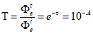
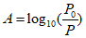
OR

Absorbance is inversely proportional to transmittance, and is typically given as a percentage
%T=T(100); as the absorbance percentage increases the relative light transmittance decreases.

The Beer-Lambert Law demonstrates that there is a proportional relationship between absorbance and the molecular structure of a tested sample. This understanding is central to the device’s ability to accurately identify contaminates, as well as quantify the degree to which contamination exists. The law can be simplified to the expression:, where is the molar absorption coefficient, is the test path length, and is the solution analyte concentration. The molar absorption coefficient is a constant that varies by compound, meaning provided the variables: Absorbance(), Length(), and Concentration() the device will be able to infer upon the molecular structure of the solution. Furthermore, represents a wavelength-dependent absorptivity coefficient, and can be written as . The units for each of the variables in the formula are as follows:
, , , and
All conversions must be made to these units.

Of note there are many types of Spectrophotometers, all of which function differently to produce different results. Atomic Absorption Spectrophotometers analyze absorbance when the tested substance atomizes, this allows for wavelength testing in the range of 185 to 900nm. In chemistry and biology, the use of a Double Beam Spectrophotometer is employed for High-performance liquid chromatography (HPLC). This is the action of “separating, identifying, and quantifying each component of a mixture”. Different chemical structures will possess different IR absorption, and these differences are recognized with an Infrared Spectrophotometer, which uses an interferometer to distinguish a pattern of wave interference called the interferogram. Another wavelength specific type is an Ultra-Violet Spectrophotometer, which induces molecular electronic transitions by interfering with sample components within the electromagnetic spectrum. Finally, the most common type: Single Beam Spectrophotometer, which is able to determine wavelength in the Ultra-Violet to Visible Spectrum. With this type a reference test is done to determine a base light intensity, then sends a single beam of light through the sample for comparison.

According to Perkin Elmer Biotechnologies, the most common type of Spectrophotometer for laboratory use is the UV/Visible. This type tends to be the most applicable to environmental, and medical research. Finally, the Bragg Spectrometer, this type utilizes x-rays and the way in which they interact with a crystal. Instead of analyzing a change in light perception, they operate under Bragg’s law which calculates molecular lattice spacing, the angle of refraction, as well as a change in wavelength. The results of this type have greatly expanded out knowledge of materials at the molecular level.

The development of hypotheses in the field of Spectrophotometry is dependent upon one’s understanding of nomenclature customary to the field. First, transmittance, in addition to the mathematical definition provided above, this term refers to a material’s ability to objectively transmit radiant energy. Which is proportional to electromagnetic radiation and “can be considered a stream of photons, radiant energy can be viewed as the energy carried by these photons”. Second, absorption, a term whose elements comprise a veritable physics giant. A material’s absorption is related to its molecular composition, specifically the electrons within the atomic makeup. The reduction of photon transmittance through a material might also be called attenuation.

Electrical Functionality:
There are many components required to ensure a Spectrophotometer is able to function as accurately as possible. The electronic design of each Spectrophotometer must work cohesively to create a well regulated and efficient system, rudimentarily the device consists of a light source, a Monochromator (electrically driven), an adjustable aperture, a photocell, an amplifier, and some sort of output display (most commonly digital).

Each type of Spectrophotometer has a specific light source, or lamp type, all of which demand a unique current. However, the type of light source varies depending on the device module and purpose. One electrical common denominator (with the exception of the UV Spectrophotometer) is the light source’s current frequency, which in all cases is continuous; this is an important extrapolation as the device’s initial design utilized Pulse-Width Modulation (PWM). The relative light intensity is dependent upon the light source’s current, which in most cases should be at the light’s maximum electrical potential.

One general commonality between all designed Spectrophotometer’s is the ability to quantify preliminary voltage draw between the Photometer and the Spectrometer. This function is vital because input current to the photocell cannot be effected by the initialization of the Spectrometer’s testing stage. There is one source of voltage, therefore current will fluctuate as more components are powered. In order to account for this fluctuation, the use of a voltage divider is often employed, which is referenced to ground.
Electrical Diagram and Mathematical Rationality:
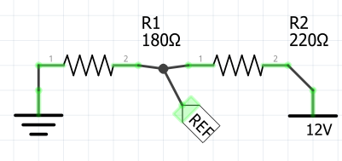
Output Equation:

The electrical precision of a Spectrophotometer is crucial to the device’s overall accuracy. The voltage at which the device functions technically won’t matter so long as change can be observed, however the greater the voltage, the greater the potential for accuracy.

The Monochromator is another component that might function electronically. Most Spectrophotometers utilize a prism to narrow and select a wavelength, this is accomplished by actuating the prism around its axis. To accomplish this a bipolar stepper motor might be utilized, which uses magnetic induction to precisely control movement. The polarity of the Electromagnetic Field alternates to rotate the motor step by step, this action is achieved through the use of an H-Bridge. The electric diagram for the induction motor is as follows:

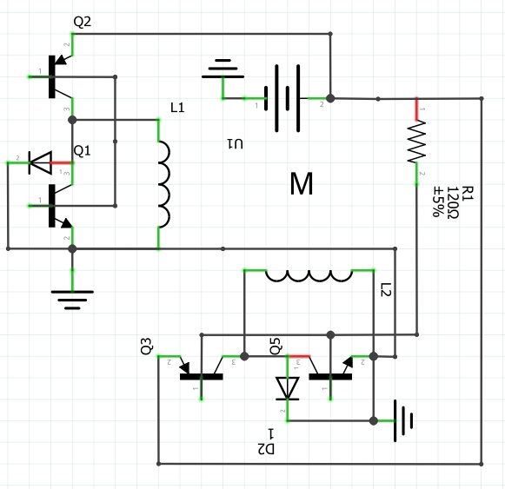
Note: The diagram is a conceptual representation; it is functionally incomplete.
Diagram created with Fritzing

The mathematical representation for rotation with respect to time is:

Where, is rotation, is the frequency of the pwm work cycle, is the motor radius, and is time.

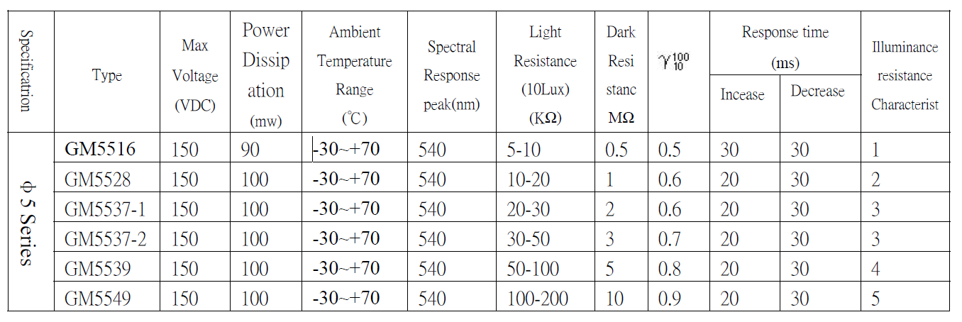
A common device for the perception of light is the photocell, also called a Photoresistor, or Light Dependent Resistor (LDR). As light exposure increases the LDR will increase its resistance, this is a property rendered unto the component as a result of its photoconductivity. This property describes the phenomenon in which “a material becomes more electrically conductive due to the absorption of electromagnetic radiation”, or radiant energy. The resistor is composed of a semi-conductive material, which has a high resistance; however, it is not a true semiconductor because it lacks a PN-Junction. The optical component is defined as passive for this reason, and as a result its spectral range typically has a maximum potential wavelength of around 540(nm).
Specifications pertain to the GM55 series Photoresistor.

Alternatively, a Photodiode might be used to perceive light, this option proves advantageous if the Spectrophotometer must exhibit sensitively to a wide range of wavelengths. As opposed to the Photoresistor, this light dependent device has a PN-Junction (it can also have a PIN Structure), and is therefore a true semiconductor. An even greater, and certainly more significant difference between the two components is the photodiode’s ability to convert photon collisions into current (photovoltaic systems are composed of photodiodes).

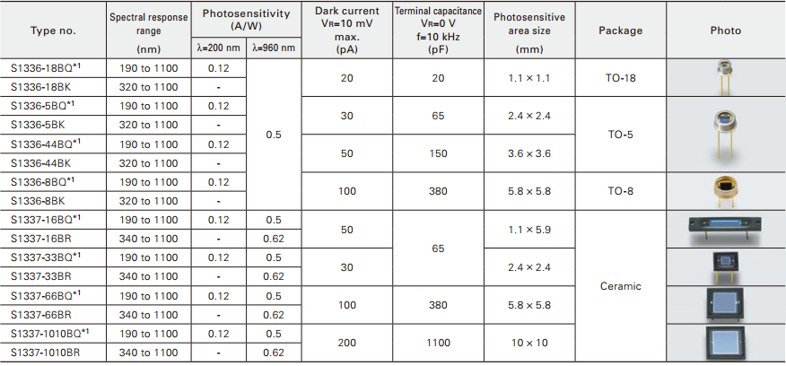

Specifications pertain to Si Photodiodes.

The primary electrical distinction between the Photoresistor and the Photodiode is the way in which they carry current. Essentially a diode is any component that carries current in one direction, but does not allow it to travel in the inverse direction, simply, diodes are polar. A PN-Junction, or positive-negative junction describes the relationship between P-Type Silicon and N-Type Silicon. The properties of both types relate to the conductor’s Fermi-level, this interaction effects the silicon’s ability to overcome its valence band and enter into the conduction band.

Once the Photometer has perceived, and proportionally altered or produced current, it must be amplified in order to provide a testable result. To this end, an Operational Amplifier (Op-Amp) is used. In order to do this an Op-Amp increases the amplitude of the input signal by adding the initial voltage (), to a baseline analog voltage () of a considerably greater value. Additionally, it utilizes a system of external components (i.e. resistors, and capacitors) that are used to make comparisons in voltage called feedback. This feedback is called gain, and defines
the ability of a two port circuit to increase the amplitude of a signal from the input to the output. The gain is given as a frequency called the gain-bandwidth. Additionally, the Op-Amp is a specific type of amplifier called a Differential Amplifier, which is the combination of a non-inverting, and inverting amplifier.

An Op-Amp is an integrated circuit which has both a Positive, and Negative input terminal. The Non-inverting Amplifier is created when the input source () is connected directly to the positive terminal, which invariably ensures the gain is positive. An Inverting Amplifier is created when a resistor () is connected from the output terminal to the negative terminal, which serves to reduce the overall gain proportionally. The use of these two circuits concurrently allows for accurate amplification with respect to the initial input source, and gives the mathematical form:

OR
Where, is a constant specific to the Op-Amp used.
The basic electrical design of an Op-Amp is as follows, note it does not account for Baseline voltage ().
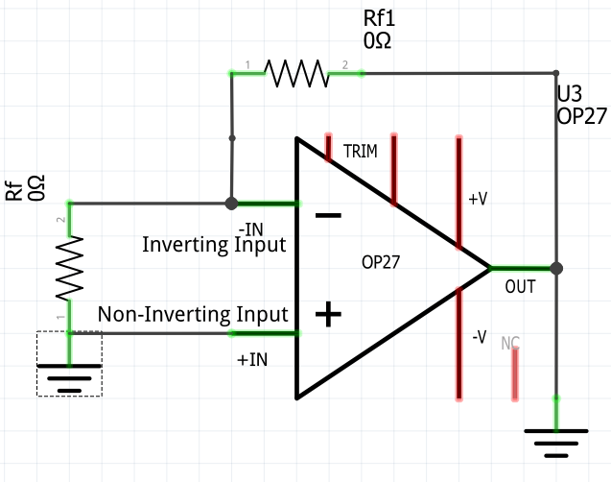

Open loop gain (standard for Spectrophotometry), is dependent upon:
between or (Inverting, and Non-Inverting)V

Closed loop gain, utilizes a voltage divider from output to inverting-input (not utilized nor shown in this thesis).

Diagram created with Fritzing

The rate at which on Op-Amp can change its voltage with respect to time is called a Slew Rate, whose unit of measure is volts per second. The slew rate is given as a minimum possible estimate, and represents the incremental rate of comparison. As it relates to a Spectrophotometer, the importance of this rating is not significant as the current comparisons will be made in a controlled testing environment, meaning the fluctuation of the input current will be suppressed.

The final major electrical component allows the now amplified current to be observed by the user. This can be accomplished either digitally, or through purely analog methods. If the output is given by way of a digital voltmeter, there must be an analog to digital converter, which would imply the use of some sort of microcontroller. This is optimal as the calculations for transmittance and absorbance would be done consistently without the risk of human error. An analog to digital converter (ADC) converts (much as it sounds) analog current into a digitally recognizable signal. The device periodically interprets an analog signal, then assigns digital values based on the observed amplitude or frequency with respect to time. The result is a translation of analog frequency to discrete-time digital output, meaning or is equal to the analog source at “distinct, separate points in time”.
Once the analog current from the Operational Amplifier has been converted into a digital signal it can then be digitally stored, calculated, and displayed.

In conjunction to Analog to Digital Conversion the Microcontroller must also make calculations and often store information for later data comparisons. The speed at which calculations are made is dependent upon the controller’s bit rate, which is given in the form bits/s, where s is one second. The ability to store bits of information is dependent upon the controller’s EEPROM (Electronically Erasable Programmable Read-Only Memory) capacity. Like traditional data storage EEPROM data is non-volatile meaning it maintains its electrical polarity position even after a power cycle is undergone. The ability to recall previous Absorbance and Transmittance calculations allows the device to pare trends to known tested solutions, which in turn increases its ability to identify the solution.
Mechanical Functionality:
A variety of components within a Spectrophotometer can, and sometimes exclusively, function without electricity. Such components can include: The Collimator, Monochromator, Cuvette, and less commonly an Analog Voltmeter. In the case that the testing environment is regulated by mechanical components the chance of human error increases, however many current Spectrophotometers utilize mechanical methods in order to maintain affordability where the use of electricity is superfluous. The most obvious analog component is the sample container, in most cases the cuvette. Typically, cuvettes are made of fused-quartz, but they can also be made of glass and in some cases higher quality plastic. While the former material is certainly more expensive, it is more effective because of its low light impedance, and is required for UV Spectrophotometers. Glass and Plastic cuvettes can be used in conjunction with most other forms of light within the electromagnetic spectrum, as long as the device is given on adequate control comparison of the cuvette with no solution in it.

A Physical Analysis of Light:
Photons are the quantum of the electromagnetic spectrum, meaning it is the smallest existing physical entity in that spectrum. Photons are elementary particles that compose the visible light spectrum (400-700nm) and other forms of electromagnet radiation such as: radio waves, microwaves, infrared, ultraviolet, and gamma radiation. The objective state of a photon falls under a quantum mechanical principle known as wave-particle duality, which defines the photon as both a particle and a wave. One distinct trait of a photon is its lack of mass. The momentum and energy of a photon is solely related to its wavelength, and exhibits spin angular momentum; a quantifiable value that is an attribute of elementary particles. Under the confines of its duality, there is no concrete size given to photons, however it can be inferred that each photon has a width that is approximately the span of its wavelength.

The energy of a photon has two quantitative attributes: frequency and wavelength, whose values are inversely proportional. Photon energy lessens as wavelength widens, while higher frequencies represent an increase in photon energy, thus energy is a property of the photon’s wavelength. Given the following hypothetical: and , both sources of light , and will exhibit the same energy as they share the same wavelength. Photon energy is calculated by the following equation:

The quotient of the equation will be given in the unit: Electronvolt (eV). An electron-volt is a unit of energy used in particle physics, its exact definition is the amount of energy gained by an electron when compelled through a potential difference of 1 volt, . Calculating photon energy can be accomplished using a few photometric attributes, , or the elementary charge is equal to the charge flow in coulombs multiplied by .
or,

As defined by the Mass-energy equivalency explanation of particle physics, the energy of a particle is equal to its mass, this principle gives the mathematical form: , where: is energy, is the mass of the entity, and is the speed of light. This understanding further demonstrates the photon’s dispensation from applied physical law, as it possesses energy without possessing mass, a virtue emblematic of its duality. For its use of both the speed of light, and Planck’s constant the technical name for this equation is the Planck-Einstein relation.

In order to complete photometric calculations, and accurately select a desired wavelength, the initial energy equation must be rewritten to solve for wavelength with respect to energy. However, this equation is incomplete as must first be converted into volts for electrical implementation. Planck-Einstein’s relation defines the wavelength of a single electron-volt at 1240nm. Considering this conversation, the complete equation for the exact calculation of wavelength with respect to voltage is as follows:
Solving for Energy:

or,

Because electrons are charged particles they are subject to inelastic scattering when they interact with photons, this interaction is called Compton Scattering. When this interaction takes place the kinetic energy of the photon is not retained and transfers to the recoil particle (electron). The transfer of energy from the incident particle (photon) results in the scattering of electrons within a material, this observation is in accordance with the conservation of energy and momentum. Mathematically an incident of Compton Scattering is defined by the formula:
..
In other words, Compton Scattering defines the oscillation of electrons with respect to the magnitude and angle (Snell’s Law) of the collision.

The molecular composition of a tested substance will determine its light absorbance; a substance with a high molecular density will have greater light absorbance, while inversely, a substance with a lower molecular density will have lesser light absorbance. The molecular structure of a substance will reflect the number of electrons, which in turn defines the potential for photon collision to induce Compton Scattering; thereby reducing the energy of collided photons, which provides a testable differential in light perception. Within a light sensitive device (i.e. Photoresistor, or Photodiode) this energy is used for specifically designed purposes, sometimes undergoing different stages of energy transformation, for example: thermal to electric.

The Image Demonstrates a Photon-Electron Collision.
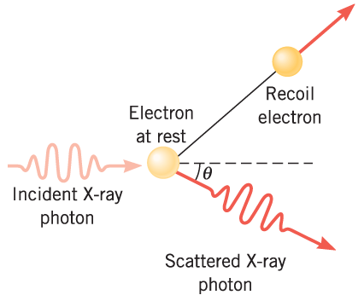
THE MOMENTUM OF A PHOTON AND THE COMPTON EFFECT.

The image above depicts a scattered photon after the collision occurs, this photon will either refract or reflect. Reflection occurs when Compton Scattering causes the incident photon to bounce back, when the opposite occurs and the photon passes through the substance, the incident photon will refract at a specific angle calculated with Snell’s Law. Absorption relates to the instance in which photons neither reflect nor refract, this occurs at high molecular densities. The observation of all three behaviors will precisely define the composition of a substance, if produced in a controlled testing environment observed Compton Scattering allows for highly accurate testing.

The specific behavior of a photon when it is undergoing a particle collision is defined by Snell’s Law or The Law of Refraction, which determines the redirected angle of a scattered photon. The result of refraction is dependent upon two variables: one, the angle that the incident photon and the recoil electron create with respect to the point of collision, and two, the specific substance through which the photon is traveling. In standard Spectrophotometry this understanding is used in order to decide the angle of the prism within the monochromatic device. The angle of refraction is calculated through the following formula:

Where, is the angle of the incident photon, and is the angle of the recoil electron. Simply put, the angle of refraction is equal to the angle of the incident photon at the moment of collision.
While Snell’s law defines the angle of incidence refraction, Bragg’s law allows for the precise calculation of photon wavelength after collision. Specially, the law refers to two principles: first, that the angle of incidence will be equal to the angle refraction (Snell’s Law), and second, the relative change in wavelength will equal an integer number of wavelengths. The precise equation for Bragg’s law is as follows:

Where, is equal to number of conditional wavelengths, is equal to photon wavelength after collision, is equal to the molecular lattice spacing of the tested material, and is equal to the angle of refraction. The variable , defines the lattice structure of the material and is therefore an indicator as to its specific composition. Bragg’s law can be rewritten to calculate the lattice distance using the following equation:

Where, is equal to the angle of refraction.

Recalling the information regarding the functionality of the Photodiode, Compton Scattering further demonstrates how electric current in produced within the semiconductor. At the point of collision, the momentum of the incident photon is transferred to the recoil electron which excites the particle. This transfer of energy produces current within the Photodiode’s P-N Junction; thus electricity is produced. As it relates to Spectrophotometry the incident photons that collide with electrons are the product of Compton Scattering after light passes through the tested solution; in other words, refracted photons will collide a second time with stationary electrons residing in the Photodiode or Photoresistor. Therefore, the relative energy transference can be represented by the following energy interaction:

Factoring Bragg’s Law:

andremain constant in accordance with Wave-Particle Duality, at the point of collision the incident photon refracts () which results in a change of wavelength (), and therefore energy. Because the energy of the perceived incident photon is predicated upon the its wavelength we might also say: .

Testing Procedures:
In order to ensure accurate results there are procedures in place for testing, additionally a Spectrophotometer must meet certain design standards. The Standard Operating Procedure (SOP) must be repeatable in Photometric Determinations, this methodical cross-compatibility serves to mitigate variations in the testing process that would otherwise interfere with test conclusions. Design Standards include: a constant testing environment, adequate amplification of the light dependent sensor, consistent mathematical analysis, and accurate means of sensor read-out. Procedural standards include, precise sample measuring, cuvette clarity, and the assembly of baseline wavelength and absorbance readings. Each of these standards must be met for the result of a Spectrophotometer to maintain its validity.

As previously mentioned, Spectrophotometers must be given a baseline control comparison of the cuvette before the sample is tested. This ensures that the result neglects any light absorption caused by the sample container. First, the user should clean and dust the cuvette to the best of his/her ability, additionally the cuvette should be completely dry before the desired sample is introduced. After it has been sufficiently cleaned the user will select the desired wavelength and place the cuvette in the device for testing, once complete (without removing the container) the sample should be introduced into the cuvette. The goal of this exact procedure is to reduce the number of times the user touches the cuvette, and will therefore result in a more accurate test.

As an added method of analysis the sample should be tested multiple times, as the result must be repeatable in order to be considered legitimate. Provided there is a linear consistency between the results the user can either average the results, or simply use the maximum absorbance calculated. Furthermore, weekly, monthly, and yearly tests should be maintained in order to ensure the continuity of the conclusion, testing frequency is one statistic with respect to time. If one perceives changes over time it will help the user deduce the source or root of the change, and in effect resolve environmental issues.
Routine accuracy testing should be undergone; such tests include a wavelength accuracy test, during which the device will tests solutions with known wavelengths. A common safe-net solution used for this test is Holmium Perchlorate, which is effective in photometric calibration. Apart from liquid testing, a glass filter might also be used to demonstrate wavelength accuracy. This is done be quantifying the Spectrometer’s light emission level, once known the user will calibrate the Monochromator in a predictable way. If the resulting wavelength conclusion is consistent with physical light calculations, then the device’s accuracy will have been ensured. These tests should be conducted in the same way as standard testing, meaning multiple tests should be done before accuracy is concluded.

An additional way to maintain a Spectrophotometer’s reliability is to compare the results of the aforementioned accuracy tests to other industry standard devices, if the results are comparable within a minimal margin of error the instrument’s accuracy can be inferred.

As in the above defined Wavelength tests, absorbance accuracy should also be ensured before any field tests are conducted. The absorbance test will be conducted with a solution that has a known density, and the user will observe the effect the solution has on the initial emitted light. One common medium for this test is Potassium Dichromate, whose absorbance is best shown at wavelengths of 320 to 350nm. Distinct absorbance recognition is vital for environmental analysis, thus quality must be ensured and the above defined method heeds the most precise results.

Being the two primary functions of this project absorbance and wavelength accuracy tests are the only two processes that require explanation, however other accuracy tests exist within the realm of photometric testing. Such tests include: stray light, resolution, and reflectance tests, if a Spectrophotometer is meant to measure any of the above attributes the user must employ each test accordingly. All of the above described tests help the user calibrate the Spectrophotometer, field testing can only commence when accurate calibration is complete.

Device Information and Specifications
General Device Overview:
The project was designed with three standards in mind: one, reliability, two, efficiency, and three, affordability. The first and most obvious standard is reliability, in order for the device to maintain its viability it must have the ability to replicate accuracy results consistently; additionally, the testing process must demonstrate an ability to make distinctions between chemical and biological contaminates. As the instrument is meant to be operated in the field, power usage is a central concern to the functionality of the system. As a result of invariable environmental conditions (externally) power preservation protocols must function efficiently to produce a well regulated method of electrical operation. In order to mitigate financial burden, the designed system specifications omit unnecessary expenses on the behalf of superfluous components, and include only low-cost, functionally adequate components.

The reliability of the device includes its longevity as well as its accuracy. The hardware is designed to reduce the probability of failure, which could result in faulty conclusions or the loss of system functionality all together. The housing is made from a robust polyester, called copolyester, which is a common 3D Printing filament. One specific advantage of copolyester is its resistance to chemical malformation, meaning water will not have a tremendous effect upon its rigidity and shape. This use this material as the device housing also fits our financial criteria, as 750g costs roughly 45.00$ USD. There are no extraneous temperature conditions regarding polyester, allowing for use in any natural climate.

The device logic boards must be protected from exterior climate conditions. While the copolyester housing serves to protect the components within the device, all system logic boards reside underneath a secondary removable layer of filament. This redundancy ensures that electrical components remain protected from external variables, and will therefore increase the longevity of the device. Furthermore, the device itself (as well as any accompanying testing tools) will be transported and stored in a weather-proof carry case.

Electrically there are some procedures required to ensure component accuracy, the first of which: The Spectrometer’s LEDs, whose exact voltage input will determine the duration of its life. In accordance with this statement all LEDs will be regulated to their respective maximum voltages (see device assembly and design for exact numbers). As an added redundancy the device operating system will routinely perform autonomous light intensity tests, should the intensity of one of the spectral LEDs lessen, the user will be notified and later calculations will account for the loss of intensity. Possible causes of light intensity loss include: system short, improper resistance (highly unlikely, however still possible), software bug, physical light obstruction, or deviations in the rotation of the monochromatic device.

The above defined copolyester housing assists in the regulation of light within the testing environment, the 3D Printing process completes in two pieces: the base housing, which consists of the device base and walls, and the device lid, which seals the testing environment. There is only one other port that would allow light to enter the system, the cuvette slit, which will remain covered as to reduce the introduction of foreign light. Just as the operating system autonomously tests the LED’s intensity, it will also test the Photometer’s light perception to ensure it is properly zeroed out. Possible causes of an unregulated testing environment include: cracked housing, improper cuvette or device sealing, electrical short, or software glitch.

Each of the above defined accuracy tests will be conducted once upon start-up, and again before the beginning of each field test. These tests are in compliance with Standard Procedures in Spectrophotometry as defined by the section Testing Procedures. For precise software protocol information see the Operating System section. Once testing has initialized it will make three of each calculation, the true product will be the average of the three.

The next major design standard is efficiency, not just of power regulation, but of processing, system architecture, and user simplicity. Electrically the device functions at 12V, this voltage is later reduced to 5V for all digital microcontrollers. Energy is only expensed when absolutely vital, after the testing process is initialized the user will be prompted to complete a series of preparation instructions (see operating system), the programmed controller acts as a Watch-dog Timer. This ensures that the device remains on only under load, when the test begins it will complete its calculations, compare, and store the results.

The photometric conclusions depend upon the algorithm administered through the Main Microcontroller, this algorithm was optimized to function on a single-thread controller. This procedure will ensure that all light comparisons are completed within a reasonable time frame, and calculations are completed using efficient data comparators which functionally reduce the consumption of processor bandwidth. Proper integration between the external analog Op-Amp and the Internal Analog-Digital Converter allows for simultaneous data calculation, comparison, and storage. Larger calculations must be completed first in order to conserve system bandwidth, a key example of which is the logarithm used to determine absorbance. After these larger calculations are complete, data comparisons will be undergone, and the results of which will be stored within the controller’s EEPROM cache.

Integrated Circuits:
There are a number of Integrated Circuits that allow the device to function, of note: The Power Supply Regulator and ADC, the Main Controller, and the Op-Amp. Each IC was integrated into the system with power efficiency in mind, therefore, many of the system power rails are regulated with voltage dividers (see Electrical Functionality section for additional information). The two MCUs that handle data are ATMega-Series Microcontrollers, both with a forward voltage of 5V and an operating current of 0.2mA, additionally each utilizes an external 16mHz oscillator. The Operational Amplifier is a Microchip MCP602, with a gain bandwidth of 3mHz.

The Power Supply Controller is the ATMega328AU, an 8bit, surface mount device. It was
programmed via ICSP (In-Circuit Serial Programmer), the primary function of this controller is
to monitor, and regulate voltage distribution. The first iteration of the device has two sources of
power, a 12V DC in and a 12V Internal Battery. In order to conserve, and properly recharge the
battery the Power Supply invokes the use of an NPN transistor, whose base polarity is dependent
upon the presence of current from the DC in socket. When the base value is high the transistor
restricts current from the battery, and serves to redirect the considerably higher amperage current
of the DC in, to the now dormant battery. This base value will be safely regulated with a voltage
divider and perceived by the Microcontroller, if low, the controller will (with the use of another
transistor) allow current to flow to the battery. Both supply sources eventually flow to the
Photometer, here the 12V source is used for Amplification; however, before this occurs the
current is reduced to 5V and sent to the Main Logic Board.

The Main Logic Board is controlled by the ATMega644AU, whose technical specifications are
almost identical to the ATMega238, the primary difference being the available I/O. it is
programmed in just the same way (ICSP), and is clocked at just the same speed. The first
function of this controller is to carry out Photometric testing as prescribed by its algorithm, after
testing is complete and it has received analog current from the Operational Amplifier, it proceeds
to complete absorbance calculations. The next task assigned to the controller is readout to the
device’s TFT Touch Screen, in accordance with the programmed operating system it both
transmits and receives information.

The last IC of note is the Op-Amp, which amplifies the analog signal from the Photometer. This device is using the Microchip MCP602, an 8 pin dual amplifier with a gain-bandwidth of 2.8mHz.. As stated in the section Electrical Functionality, each Operational Amplifier has a Slew Rate. This rate defines the rate at which voltage output is updated when a change in input voltage occurs, the slew rate of the MCP602 stands at 2.3 V/uS.

For complete operating conditions, and individual specifications see Component Specifications section.

Light Emitting Diodes:
Light Emitting Diodes (LEDs) are the light producing components within the Spectrometer, these semi-conductors are advantageous for many reasons. One such reason: its power efficiency, the maximum forward current for the majority of standard LEDs stands within the range of 20-50mA. If these conditions are met the component will produce high intensity light within its respective wavelength allowing for distinct spectrum control. Because of this quality LEDs exhibit monochromatic potential, and therefore allow the device Spectrometer to function without a traditional prism. Another advantage is the size of the bulb, which in this particular instance measures to 5mm; this allows for easy integration and control. Specially, this device uses three different types of LEDs, they are as follows: RGB, White, and IR.

As mentioned before LEDs are semi-conductors, meaning they possess a P-N Junction. This junction is composed of anode and cathode pins where positive current is applied to the anode and negative, or ground is applied to the cathode. The resulting reaction is called electroluminescence, a term which refers to the action in which active current fills empty electron holes within a conductive material. The filling of these holes results in photon production, and the emitted wavelength is proportional to the energy (current) applied across the P-N Junction. Through the principles defined in the section A Physical Analysis of Light we can calculate perceived light wavelength based on energy, and inversely we can calculate energy based on the perceived wavelength. In order to guarantee consistency, the current supplied to system LEDs will remain under constant regulation; the energy given must remain a constant for accurate calculations. The three LEDs used in the device are similar in design, with the notable exception of the RGB, which consists of three diodes with a common ground. This LED is capable of producing light in the range of 400-700nm (visible light), while it is capable of producing white light it cannot be adequately diffused in the provided space. Thus, a single diode, pure white LED is used for general spectral comparisons.

As Snell’s law suggests the angle of light projection is a vital variable in the perceived wavelength. As such each LED is given a standard optimal viewing angle, typically provided in the component’s datasheet. Because each LED has a standard 5mm bulb they will all have the same viewing angle, to account for this the LED matrix in the Spectrometer is designed to keep each LED in line.

Spectrometer:
Before Photometric light comparison can take place, the operating system must obtain all initial light variables (i.e. Photon Energy, LED Voltage, and Emitted Wavelength). The Electroluminescence of each LED is different, and as a result the chemical makeup of each semiconductor is different. Below are examples of analog calculations that do not account for the chemistry of the in question LED, therefore the result of each calculation will be an approximation. The exact margin of error will be derived from the Target LED’s specifications, where, and
Where,
Planck’s-Einstein Relation:
Standard Current Force , Elementary Charge .
1) 2)

The equation provides an analog result, one which does not account for the precise chemistry of the LED, nor the luminescent viewing angle. Additionally, observe the correlation between energy and emitted wavelength; as previously stated photon energy and wavelength are inversely proportional, the result of these calculations demonstrate this relationship. To ensure voltage is distributed accurately and safely the product of the energy equation will be converted into a pwm frequency. The conversion maximum is defined by the LEDs maximum voltages, so first we must determine which LED will be used. Both the UV, and IR LEDs will be set to their standard electrical loads.

Target LED Specifications
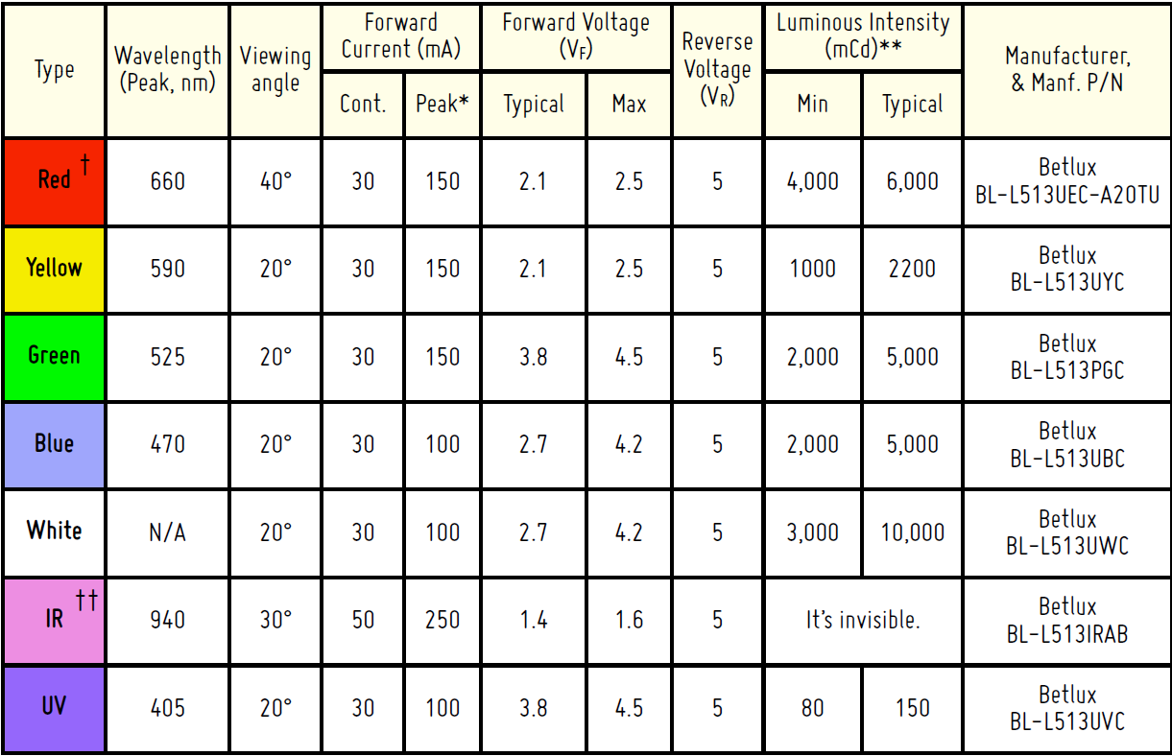

Monochromatic wavelength emission is dependent upon the selected LED type, and the current supplied to that LED. For the sake of simplicity, the UV and IR LEDs will always be granted standard emissions under their typical electrical load, and . In order to select a wavelength in the visible light spectrum (400-700nm), we must invoke Pulse-Width Modulation to supply current to the target diodes within the 5mm LED. Any standard MCU with PWM capabilities gives the frequency of the duty cycle a value between 0-255, these fluctuations are not Sine waves but instead Rectangular Pulse Waves. This value represents the total amount of time a PWM channel is HIGH during one cycle, preliminary voltage calculations will be taken at Typical LED Electrical load.

Color (C) | Wavelength(nm)
Red | 700nm
Orange | 602nm
Yellow | 508nm
Green | 520nm
Blue | 460nm
Indigo | 440nm
Violet | 400nm

Spectral analysis is designed to cover the primary wavelengths within the visible light spectrum, first the device operating system must determine the average rate of change () for pwm variations.

Having calculated the average rate of change with respect to (which will hence forth retain the variable ) we know that variations in the pwm workcycle cannot drop below . Next, must be given a time () frame where,
and, , therefore:

Essentially this shows how much bandwidth the MCU pwm channel can consume. Now, we calculate the bandwidth required to increase the voltage () through all variations of using:
and,
Which is: total MCU bandwidth.

Software integration begins by setting the value to the extrema defined by the voltage rate of change. After the range is set the workcycle will initialize, resulting in complete visible light production from the Monochromator.

Solving for the newly defined value with respect to the function maximum:
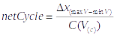
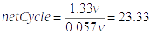
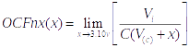

Further: So, cycles for full spectral analysis.

Using this function instead of appending absolute values to each of our wavelengths within a static array allows for full spectral analysis, rather than constant values. In addition, the function will demonstrate change . If the aligned LED is not the correct type to produce the desired wavelength, the Monochromator will rotate the LED Matrix Board to the correct type. The will of course occur before the Main Logic Board provides current to the LED, having just three types of LEDs each rotation will be a third of the total number of motor steps. For additional information regarding Spectrometer design see Device Assembly and Design.
Example (1):
PWM Voltage Value: Work cycle @ 2.37v:
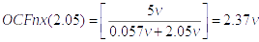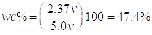

Photometer:
Photometric calculations take place when the Light Dependent Device (in this case a S1337-1010BQ Photodiode) within the Photometer perceives a change in light intensity. In accordance with the description given in A Conceptual Analysis of Spectrophotometry the absorbance of the test material is as follows: , where, . Additionally, the values of Transmittance () and Absorbance () are inversely proportional; meaning that the material’s ability to transmit light through its mass will mean that it has less Absorbance. Once the analog output from the Photometer is amplified, we can begin to define our variables.
Photometric calculations take place when the Light Dependent Device (in this case a S1337-1010BQ Photodiode) within the Photometer perceives a change in light intensity. In accordance with the description given in A Conceptual Analysis of Spectrophotometry the absorbance of the test material is as follows: , where, . Additionally, the values of Transmittance () and Absorbance () are inversely proportional; meaning that the material’s ability to transmit light through its mass will mean that it has less Absorbance. Once the analog output from the Photometer is amplified, we can begin to define our variables.
Photometric calculations take place when the Light Dependent Device (in this case a S1337-1010BQ Photodiode) within the Photometer perceives a change in light intensity. In accordance with the description given in A Conceptual Analysis of Spectrophotometry the absorbance of the test material is as follows: , where, . Additionally, the values of Transmittance () and Absorbance () are inversely proportional; meaning that the material’s ability to transmit light through its mass will mean that it has less Absorbance. Once the analog output from the Photometer is amplified, we can begin to define our variables.
Photometric calculations take place when the Light Dependent Device (in this case a S1337-1010BQ Photodiode) within the Photometer perceives a change in light intensity. In accordance with the description given in A Conceptual Analysis of Spectrophotometry the absorbance of the test material is as follows: , where, . Additionally, the values of Transmittance () and Absorbance () are inversely proportional; meaning that the material’s ability to transmit light through its mass will mean that it has less Absorbance. Once the analog output from the Photometer is amplified, we can begin to define our variables.
Photometric calculations take place when the Light Dependent Device (in this case a S1337-1010BQ Photodiode) within the Photometer perceives a change in light intensity. In accordance with the description given in A Conceptual Analysis of Spectrophotometry the absorbance of the test material is as follows: , where, . Additionally, the values of Transmittance () and Absorbance () are inversely proportional; meaning that the material’s ability to transmit light through its mass will mean that it has less Absorbance. Once the analog output from the Photometer is amplified, we can begin to define our variables.

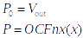 Therefore, 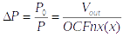 And,

Example(2): Given Example(1) in Spectrometer section, :
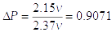Thus,

With Transmittance defined we can now solve for Absorbance using the above prescribed logarithm:
So, 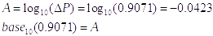
As clearly shown, the relationship between Absorbance and Transmittance is: . If the Transmittance is high then the Absorbance will be low, and if Absorbance is high then the Transmittance will be low. The other, and perhaps more accurate method of finding Absorbance relies on three variables: , , and , the complete equation is:

Just as Transmittance and Absorbance, the calculation of wavelength requires the observation of change in perceived light intensity (). The final voltage can then be converted into Electron-volts for final energy conversion. The following example assumes from Example(2).

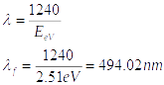
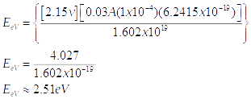
Photon Energy : Therefore,

At this point we have calculated the perceived final wavelength (), and with it we can create a differential that analyzes the structure of the material. As shown in the Spectrometer section, the device uses a wide spectrum of wavelengths, so at different increments in the pwm fluctuation algorithm we can make inferences regarding the structure of the material. One increment of in: is equal to one calculation of . The result of each incremental calculation will be stored in an array for further data analysis, for details concerning mathematical pattern analysis see the Operating System section.

Device Assembly and Design
The following section describes each of the device’s designed components, as well the methods by which they were made. Each Circuit Board was designed with Eagle CAD , the device drawing were created with AutoCad, and all project calculations were written with MathType. Please visit the accompanying websites for additional application information. Each PCB is composed of either 1, or 2 layers, ones with two require vias in to make a connection.

Design Overview:

Circuit Boards:
Each logic board is controlled as defined in the Integrated Circuits section, this section will elaborate upon the way in which each board functions. The individual circuit boards are as follows: The Main Logic Board, Photometric Logic Board, Power Supply Board, Spectrum LED Board, and the Indicator Board. The combination of the motor control board, and the LED Matrix Board make the Monochromatic Circuit. The designs for each board can be found below, as well as a description of each.

The PSB or Power Supply Board is responsible for all voltage regulation and distribution within the device. As previously mentioned it is controlled by the ATMEGA328, and was programmed via ICSP. It utilizes two transistors, and a system of voltage dividers that help calculate battery capacity and efficiently recharge it when plugged in. The logic board contains a digital output header for external indicator LEDs, below are the circuit design and schematic.

PSB – Circuit PCB
Design note: Blue traces indicate bottom layer, and Red traces indicate top layer. Green pads indicate through hole components, as well as layer vias. Circuit created with EagleCAD (http://www.autodesk.com/products/eagle/overview).

General Circuit Overview:
Its basic function is to alternate between two separate power supplies under defined circumstances. Additionally, the MCU will calculate remaining battery power and send the result of that calculation to the Main Logic Board for user display.

T1 – Transistor restricts GND from the Battery Input when DC IN is present.
R1, R2 – Voltage divider where: R1 = 100, R2 = 72.
D1, D2 – Forms a rectifier circuit ensuring complete GND source Separation.
C1 – 12v Pickup Capacitor, C2 – 5v Pickup Capacitor.
C3, C4 – XTAL Flucuation Capacitors =22pF
XTAL – 16mHz

Circuit Board Production:
After each circuit was designed, they were printed onto photo paper for easier transference when heat is applied. Each piece of paper was painted with a thin layer of clear finish to increase its ability to absorb, and transfer toner. This results in higher resolution traces, and significantly decreases the chances of failure during etching. After ink transference is complete, each trace is inspected and if insufficiently covered, marked over with a thin point permanent marker. However, before the circuit is applied to the copper clad PCB, they must be sanded to increase surface area, and cleaned with isopropyl alcohol to remove any residue. Once the boards have been adequately prepared, the paper is lined up using the printed index corner. After it has been meticulously aligned an iron is applied to the board until all toner has transferred onto the PCB. This process requires a considerable amount of force, as well as time, for acceptable results all toner must be transferred. After the top layer is complete, the paper will be flipped for the bottom layer.

Etching is accomplished through a 1:1 ratio of Hydrochloric Acid and Hydrogen Peroxide. Once the PCB is submerged in acid, it is constantly moved in an actuating tray. This further speeds up the etching process, and results in an even and complete job. Total etching time takes around 15 minutes; after which it is inspected for completion. A byproduct of this reaction is Cupric Chloride, and Chlorine Gas. Cupric Chloride effectively adds to the corrosive properties of the acid, and the Chlorine Gas must be safely ventilated. An alternative etching solution is Ferric Chloride, however this chemical takes longer and is much harder to dispose of safely.

Once etching is complete the PCB is lightly sanded with low grit sand paper, this removes all remaining printer toner and reveals copper traces. In order to increase PCB solderability it is submerged in liquid tin, which coats each copper trace. Additionally, this will also increase the longevity of the PCB. After approximately 5 minutes the PCB is removed from the liquid and cleaned thoroughly with water. At this point a layer of UV Curable solder mask is applied to each side of the PCB, once dry it is placed under a UV lamp for curing. Once the PCB is completely dried, all through hole pads are milled with a dremel and each SMD pad is checked for any damages.

The final step is soldering all components to the PCB. Typically, I begin with SMD resistors and capacitors, as these are the smallest and most fragile pieces. Next the MCU is added (if required), a small amount of flux is added to each MCU side to isolate the SMD pads. Before continuing to the vias, each pad is inspected under a magnifying glass. The last additions to the PCB are through-hole components, and headers which can simultaneously serve as layer vias. Before the PCB is installed into the device housing, it is programmed and tested for any defects.

Device Operating System:
The two MCUs in the device are programmed through the same ISCP port, VCC input is connected to a switch for cross programmability. All code is compiled from C++ through the default AVR SDK Atmel Studio, the only third party resource used is the TFT LCD library. All Atmel frameworks including: avr/io.h, util/delay.h, etc. belong to Atmel Corporation (http://www.atmel.com/).

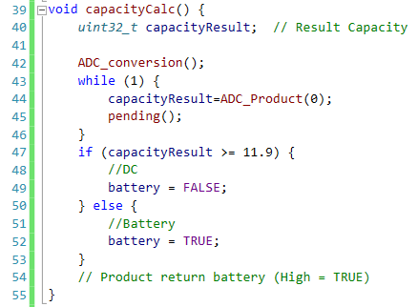
The ATMega328P used in for the PSB is used to calculate available power, and with the result determine the necessity to charge the battery. The PSB will interpret this capacity and send an analog signal to the Main Logic Board for user output, the conditions for that scenario are as follows:

Where line 40’s variable capacityResult is equal to:
The range of is = volts respectively.

Line 42 runs the method ADC_conversion(), which sets the ADC up to receive current on any of the Analog Bus Channels. Line 44 sets the previously created integer capacityResult to the product of the method ADC_Product. The ADC buffer rate is defined by the pending() method on line 45.

ADC_Covversion Method:
ADMUX is a protocol that initializes the ADC, ADCSRA clears all available Analog registers.

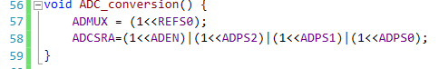

ADC_Product Method:
The method only returns ADC Product when ADCSCRA bus is receiving current, further optimizing the work load.
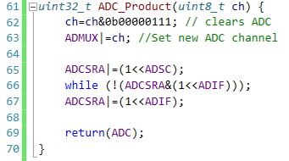

Pending Method:
The MCU’s Internal 16bit counter is used to set a high buffer rate of up to 65536 iterations.
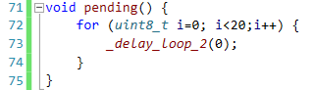

The main program thread alternates the value one of the external serial channels (PORTB6) for the device power indicator. After which the capacity is calculated by running the function capacityCalc() as defined above, the result of this function returns the public Boolean battery. If the capacity calculations indicate the presence of current from DC In, the Boolean will be set to false and the regulating NPN transistor value will be set to high. However, if the product indicates sole battery reliance the value of the transistor will be set to low, thus restricting a charge current to the battery.
Main Method:
PORTB6 is the VCC indicator channel, and PORTB5 is the NPN dependent channel.
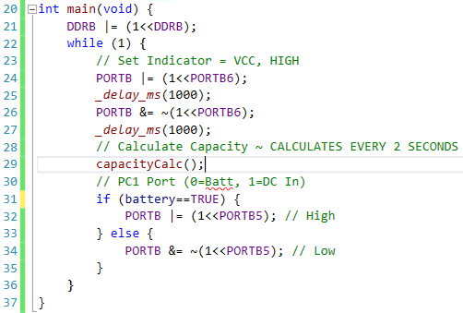

The Main Logic Board receives analog signals from different circuits in the device, the first signal identified is the PSB’s PORTB current. This ensures that the device has sufficient power to complete its calculations accurately. The startUp() method also ensures that information is returning from both the Photometric Logic Board, and Monochromatic Logic Board.

Device Housing:
The prototype was designed with total functionality in mind, the invention itself is subject to many changes that will reduce the size and current draw. As previously mentioned all user output will be given through a 2.8” TFT Touch Screen.

Tests and Results
Using a carefully designed experiment the overall accuracy of the Spectrophotometer can be tested. The variables integral to the experiment were consistency regulated to ensure controlled, and reliable results (citation needed). First, the ratio between water and the introduced contaminate were kept at a mere .
Conclusion
Restated, the initial hypothesis was: given a vast spectrum of wavelengths, and a statically significant light differential, a specially designed Spectrophotometer will have the ability to interpret biological and chemical contamination types. This was the goal of this project, and to that end the original question remains unanswered. However, the designed device did resolve many of the human interpretation errors with the CBT process. Meaning the product of quality testing is objectively, and consistently displayed to the user. n

References

Appendices
9.1 Appendix A: Pertaining to Water

9.2 Appendix B: Pertaining to Radiometry

Absorptance: represents a solution’s ability to absorb radiant energy, and the degree to which it allows that energy to be transmitted through it’s mass.
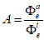
where,
Is the radiant flux absorbed by the solution.
Is the radiant flux received by the solution.
Hemispherical absorptance:

or
Spectral hemispherical absorptance:
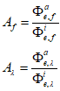
Is the spectral radiant flux in frequency absorbed by the solution.

where,
Is the spectral radiant flux in frequency received by the solution.
Is the spectral radiant flux in wavelength absorbed by the solution.
Is the spectral radiant flux in wavelength received by the solution.

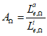
where,
Is the radiance absorbed by the solution.
Is the radiance received by the solution.
Directional absorptance:

Spectral directional absorptance:
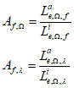
Is the spectral radiance in frequency absorbed by the solution.
where,
Is the spectral radiance in frequency received by the solution.
Is the spectral radiance in wavelength absorbed by the solution.
Is the spectral radiance in wavelength received by the solution.

Attenuation: is the loss of radiant flux intensity through a solution, induced via processes including: absorption, reflection, and/or, scattering.

Attenuation coefficient(s): defines the solution’s resistance to radiant transmittance, and therefore relates to the molecular structure/density of the solution. Is equal to the sum the coefficients for each of the processes by which radiant flux intensity is reduced (i.e. absorption, reflection, and/or, scattering).

Hemispherical attenuation coefficient:
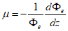
where,
Is the radiant flux.
Is the path length of light.

Spectral hemispherical attenuation coefficient:
or
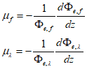
where,
Is the spectral radiant flux in frequency.
Is the spectral radiant flux in wavelength.

Directional attenuation coefficient:
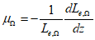
where,
Is the radiance.

Spectral directional attenuation coefficient:
or
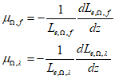
Is the spectral radiance in frequency.
Is the spectral radiance in wavelength.
where,

Mass attenuation coefficients:
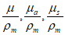
where,
Is the mass density.
Are attenuation coefficients.

Natural Logarithm: is a given number’s logarithm given the base of the definable constant, e, which approximates 2.718281828459. Typically written as:

Optical depth: is the natural logarithm of the percentage of absorption through a solution, denoted by , it is approximately equal to a solution’s attenuation (ergo, it’s absorption).
is the radiant flux received by the solution.

is the radiant flux transmitted by the solution.

Is the transmittance of the solution.
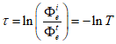
where,

Absorbance related to optical depth by:
where A is absorbance.

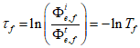
Optical depth (Spectral):
Spectral optical depth in frequency:

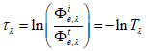
Spectral optical depth in wavelength:

where,

Is the spectral radiant flux in frequency received by the solution.

Is the spectral radiant flux in frequency transmitted by the solution.

Is the spectral transmittance in frequency of the solution.

Is the spectral radiant flux in wavelength received by the solution.

Is the spectral radiant flux in wavelength transmitted by the solution.

Is the spectral transmittance in wavelength of the solution.

Related to Spectral Absorbance by:
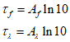
where
Is the spectral absorbance in frequency.
where
Is the spectral absorbance in wavelength.

Related to Attenuation by: the optical depth is approximately equal to attenuation provided the solution’s absorbance is less than 1 (100% absorption/0% transmittance), and radiant emittance of the solution is less than the optical depth.
Is the radiant power transmitted by the solution.
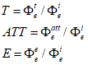
where
Is the radiant power attenuated by the solution.
Is the radiant power received by the solution.
Is the radiant power emitted by the solution.
or
where

Related to Attenuation, and the Beer-Lambert law:
thus
if
and

Related to Attenuation coefficient:
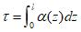
where
Is the path length through the solution.
Is the attenuation coefficient.

Radiometry: the methods by which electromagnetic radiation is observed/quantified, optical radiometry quantifies radiant energy in space, while photometric radiometry observes the behaviors and interactions of light.

Relationship between frequency and wavelength:

Name | Symbol | Unit Name | Unit Symbol | Dimension | Description
Radiosity |  | watt/square metre |  |  | Radiant flux leaving (emitted, reflected and transmitted by) a surface per unit area. This is sometimes also confusingly called "intensity".
Radiance |  | watt/steradian/square metre |  |  | Radiant flux emitted, reflected, transmitted or received by a surface, per unit solid angle per unit projected area. This is a directional quantity. This is sometimes also confusingly called "intensity".
Radiant Energy |  | joule |  |  | Energy of electromagnetic radiation
Radiant Energy Density |  | joule/cubic metre |  |  | Radiant energy per unit volume.
Radiant Flux |  | watt |  |  | Radiant energy emitted, reflected, transmitted or received, per unit time. This is sometimes also called "radiant power".
Radiant Intensity |  | watt/steradian |  |  | Radiant flux emitted, reflected, transmitted or received, per unit solid angle. This is a directional quantity.
Spectral Flux |  | watt/hertz or watt/per metre |  |  | Radiant flux per unit frequency or wavelength. The latter is commonly measured in W⋅nm−1.
Spectral Intensity |  | watt/steradian/Hz or watt/steradian/metre |  |  | Radiant intensity per unit frequency or wavelength. The latter is commonly measured in W⋅sr−1⋅nm−1. This is a directionalquantity.
Spectral Radiance | Le,Ω,ν[nb 3]  or  Le,Ω,λ[nb 4] | watt per steradian per square metre per hertz  or  watt per steradian per square metre, per metre | W⋅sr−1⋅m−2⋅Hz−1  or  W⋅sr−1⋅m−3 | M⋅T−2  or  M⋅L−1⋅T−3 | Radiance of a surface per unit frequency or wavelength. The latter is commonly measured in W⋅sr−1⋅m−2⋅nm−1. This is a directionalquantity. This is sometimes also confusingly called "spectral intensity".
Irradiance Flux Density | Ee[nb 2] | watt per square metre | W/m2 | M⋅T−3 | Radiant flux received by a surface per unit area. This is sometimes also confusingly called "intensity".
Spectral Irradiance Spectral Flux Density | Ee,ν[nb 3]  or  Ee,λ[nb 4] | watt per square metre per hertz  or  watt per square metre, per metre | W⋅m−2⋅Hz−1  or  W/m3 | M⋅T−2  or  M⋅L−1⋅T−3 | Irradiance of a surface per unit frequency or wavelength. This is sometimes also confusingly called "spectral intensity". Non-SI units of spectral flux density include jansky (1 Jy = 10−26 W⋅m−2⋅Hz−1) and solar flux unit(1 sfu = 10−22 W⋅m−2⋅Hz−1= 104 Jy).
Spectral Radiosity | Je,ν[nb 3]  or  Je,λ[nb 4] | watt per square metre per hertz  or  watt per square metre, per metre | W⋅m−2⋅Hz−1  or  W/m3 | M⋅T−2  or  M⋅L−1⋅T−3 | Radiosity of a surface per unit frequency or wavelength. The latter is commonly measured in W⋅m−2⋅nm−1. This is sometimes also confusingly called "spectral intensity".
Radiant Exitance | Me[nb 2] | watt per square metre | W/m2 | M⋅T−3 | Radiant flux emitted by a surface per unit area. This is the emitted component of radiosity. "Radiant emittance" is an old term for this quantity. This is sometimes also confusingly called "intensity".
Spectral Exitance | Me,ν[nb 3]  or  Me,λ[nb 4] | watt per square metre per hertz  or  watt per square metre, per metre | W⋅m−2⋅Hz−1  or  W/m3 | M⋅T−2  or  M⋅L−1⋅T−3 | Radiant exitance of a surface per unit frequency or wavelength. The latter is commonly measured in W⋅m−2⋅nm−1. "Spectral emittance" is an old term for this quantity. This is sometimes also confusingly called "spectral intensity".
Radiant Exposure | He | joule per square metre | J/m2 | M⋅T−2 | Radiant energy received by a surface per unit area, or equivalently irradiance of a surface integrated over time of irradiation. This is sometimes also called "radiant fluence".
Spectral Exposure | He,ν[nb 3]  or  He,λ[nb | joule per square metre per hertz  or  joule per square metre, per metre | J⋅m−2⋅Hz−1  or  J/m3 | M⋅T−1  or  M⋅L−1⋅T−2 | Radiant exposure of a surface per unit frequency or wavelength. The latter is commonly measured in J⋅m−2⋅nm−1. This is sometimes also called "spectral fluence".
Hemispherical Emissivity | ε |  |  | 1 | Radiant exitance of a surface, divided by that of a black body at the same temperature as that surface.
Spectral Hemispherical Emissivity | εν  or  ελ |  |  | 1 | Spectral exitance of a surface, divided by that of a black body at the same temperature as that surface.
Directional Emissivity | εΩ |  |  | 1 | Radiance emittedby a surface, divided by that emitted by a black body at the same temperature as that surface.
Spectral Directional Emissivity | εΩ,ν  or  εΩ,λ |  |  | 1 | Spectral radiance emitted by a surface, divided by that of a black body at the same temperature as that surface.
Hemispherical Absorptance | A |  |  | 1 | Radiant flux absorbed by a surface, divided by that received by that surface. This should not be confused with "absorbance".
Spectral Hemispherical Absorptance | Aν  or  Aλ |  |  | 1 | Spectral flux absorbed by a surface, divided by that received by that surface. This should not be confused with "spectral absorbance".
Directional Absorptance | AΩ |  |  | 1 | Radiance absorbed by a surface, divided by the radiance incident onto that surface. This should not be confused with "absorbance".
Spectral Directional Absorptance | AΩ,ν  or  AΩ,λ |  |  | 1 | Spectral radiance absorbed by a surface, divided by the spectral radiance incident onto that surface. This should not be confused with "spectral absorbance".
Hemispherical Reflectance | R |  |  | 1 | Radiant flux reflected by a surface, divided by that received by that surface.
Spectral Hemispherical Reflectance | Rν  or  Rλ |  |  | 1 | Spectral flux reflected by a surface, divided by that received by that surface.
Directional Reflectance | RΩ |  |  | 1 | Radiance reflectedby a surface, divided by that received by that surface.
Spectral Directional Reflectance | RΩ,ν  or  RΩ,λ |  |  | 1 | Spectral radiance reflected by a surface, divided by that received by that surface.
Hemispherical Transmittance | T |  |  | 1 | Radiant flux transmitted by a surface, divided by that received by that surface.
Spectral Hemispherical Transmittance | Tν  or  Tλ |  |  | 1 | Spectral flux transmitted by a surface, divided by that received by that surface.
Directional Transmittance | TΩ |  |  | 1 | Radiance transmitted by a surface, divided by that received by that surface.
Spectral Directional Transmittance | TΩ,ν  or  TΩ,λ |  |  | 1 | Spectral radiance transmitted by a surface, divided by that received by that surface.
Hemispherical Attenuation Coefficient | μ | reciprocal metre | m−1 | L−1 | Radiant flux absorbed and scattered by a volume per unit length, divided by that received by that volume.
Spectral Hemispherical Attenuation Coefficient | μν  or  μλ | reciprocal metre | m−1 | L−1 | Spectral radiant flux absorbed and scattered by a volume per unit length, divided by that received by that volume.
Directional Attenuation Coefficient | μΩ | reciprocal metre | m−1 | L−1 | Radiance absorbed and scattered by a volume per unit length, divided by that received by that volume.
Spectral Directional Attenuation Coefficient | μΩ,ν  or  μΩ,λ | reciprocal metre | m−1 | L−1 | Spectral radiance absorbed and scattered by a volume per unit length, divided by that received by that volume.

9.3 Appendix C: Pertaining to Spectrophotometry

9.4 Appendix D: Pertaining to Device

